BLOOMINGDALE BOUROUGH BOARD OF HEALTH
REGULAR MEETING MINUTES – January 7, 2019

- Call to Order.
Ms. Petersen called the meeting to order at 7:31 p.m.

- Roll Call.
Present: Petersen, Carney, Tierney, Fallon and Lovelace
Also Present: Gail Gratzel, Assistant Health Officer
Tim Zachok, REHS

- Approval of Minutes.
Motion was made by Ms. Carney to approve the December 3, 2018 minutes as presented. This motion was seconded by Ms. Tierney and was unanimously approved.

- Acceptance of Reports
After discussion of the presented reports on motion by Ms. Carney with a second by Ms. Fallon the Health Department Reports were approved as submitted and unanimously approved.

- Unfinished Business
Bloomingdale Health Center – Legionella Update: Ms. Gratzel reported that the chlorine pumps are installed and in use. The last round of sampling results showed 30% of the outlets to contain Legionella. The Health Center is continuing to flush the system, and the health department has reached out to the state for guidance. The water will continue to be tested.

- New Business
Motion was made by Ms. Carney to nominate Ms. Petersen for the position of president. This motion was seconded by Ms. Fallon and unanimously approved.
Motion was made by Ms. Carney to nominate Ms. Innamorato for the position of president. This motion was seconded by Mr. Lovelace and unanimously approved.
Motion was made by Ms. Fallon to nominate Ms. Carney for the position of secretary. This motion was seconded by Ms. Tierney and unanimously approved.

- Public Discussion
Motion was made by Ms. Fallon to open the meeting to public discussion. This motion was seconded by Ms. Tierney and all voted in favor. As there was no public wishing to address the Board, motion was made by Ms. Fallon to close the meeting to public discussion. This motion was seconded by Ms. Carney and all voted in favor.

- Adjournment
Motion was made by Mr. Lovelace to adjourn the meeting at 7:52 p.m. This motion was seconded by Ms. Fallon and all voted in favor.

Approved:
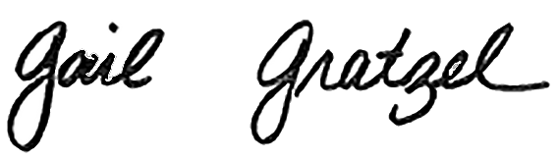
Gail Gratzel, MPH
Assistant Health Officer

